**Web Lab**

**Lab No.1**

**Task 1:**

<!DOCTYPE html>

<html lang="en">

    <head>

        <meta charset="utf-8">

        <meta name="viewport" content="width=device-width, initial-scale=1.0">

        <title>Task 1 </title>

    </head>

    <body>

        <h1>My hobbies</h1>

        <h2>Cricket</h2>

        <h3>Running</h3>

        <h4>Table Tennis</h4>

        <h5>Video Gaming</h5>

        <h6>Programing</h6>

    </body>

</html>

**Task 2:**

<!DOCTYPE html>

<html lang="en">

    <head>

        <meta charset="utf-8">

        <meta name="viewport" content="width=device-width, initial-scale=1.0">

        <title>Task 2</title>

    </head>

    <body>

        <h1><b>Using bold Style.</b></h1>

        <p>Lorem ipsum dolor sit, amet consectetur adipisicing elit. Voluptas placeat nostrum voluptatum, laboriosam velit aliquid commodi odio deserunt ea.</p>

        <h1><i>Using italic Style.</i></h1>

        <p>Lorem ipsum dolor sit amet consectetur adipisicing elit.Reiciendis minus, asperiores nobis praesentium qui totam.</p>

    </body>

</html>

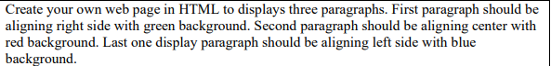**Task 3:**

<!DOCTYPE html>

<html lang="en">

    <head>

        <meta charset="utf-8">

        <meta name="viewport" content="width=device-width, initial-scale=1.0">

        <title>Task 3</title>

    </head>

    <body>

        <p style="text-align: right;"><span style="background-color: green;">Lorem ipsum dolor sit amet, consectetur adipisicing elit. In voluptates modi voluptatum quisquam necessitatibus voluptatibus aut perspiciatis illo quidem quis sequi natus atque.</span></p>

        <p style="text-align: center;"><span style="background-color: red;">Lorem ipsum dolor sit amet, consectetur adipisicing elit. In voluptates modi voluptatum quisquam necessitatibus voluptatibus aut perspiciatis illo quidem quis sequi natus atque.</span></p>

        <p style="text-align: left;"><span style="background-color: blue;">Lorem ipsum dolor sit amet, consectetur adipisicing elit. In voluptates modi voluptatum quisquam necessitatibus voluptatibus aut perspiciatis illo quidem quis sequi natus atque.</span></p>

    </body>

</html>

**Task 4:**

<!DOCTYPE html>

<html lang="en">

    <head>

        <meta charset="utf-8">

        <meta name="viewport" content="width=device-width, initial-scale=1.0">

        <title>task4</title>

        <style>

            .seprator{

                border: none;

                height: 5px;

                width:100%;

                background-color: yellow;

            }

        </style>

    </head>

    <body>

       <p>Lorem, ipsum dolor sit amet consectetur adipisicing elit. Iusto vero expedita, officiis dicta natus quasi, consequatur minima asperiores assumenda laudantium nulla. Sapiente vel animi et molestiae.</p>

       <div class="seprator" ></div>

       <p>Sit amet consectetur adipisicing elit. Dolorum atque blanditiis soluta cumque cupiditate fugit, ipsa quae ipsum praesentium officia enim sed mollitia magnam explicabo dolorem quia natus eveniet omnis.</p>

    </body>

</html>

**Task 5:**

<!DOCTYPE html>

<html lang="en">

<head>

    <meta charset="utf-8">

    <meta name="viewport" content="width=device-width, initial-scale=1.0">

    <title>Task 5 </title>

</head>

<body>

    <p><FONT SIZE="+3" FACE="Arial Black" >This is the first paragraph. <br> It has five lines of text. <br> The font is Arial Black. <br> The

        font size is increased by 3 pixels. <br> Styled as per requirements.</FONT></p>

    <p style="color:green;"><FONT SIZE="+5" FACE=" Algerian">This is the second paragraph. <br> It has five lines of text. <br> The font is Algerian. <br> The

        font size is increased by 5 pixels. <br> The text color is green.</FONT></p>

    <p style="color:green;"><FONT SIZE="+5" FACE="Bodoni MT">This is the third paragraph. <br> It has five lines of text. <br> The font is Bodoni MT. <br> The

        font size is increased by 5 pixels. <br> The text color is green.</FONT></p>

    <p><FONT SIZE="+3" FACE="Book Antiqua">This is the fourth paragraph. <br> It has five lines of text. <br> The font is Book Antiqua. <br>

        The font size is increased by 3 pixels. <br> Styled as per requirements.</FONT></p>

</body>

</html>

**Task 6:**

<!DOCTYPE html>

<html lang="en">

<head>

    <meta charset="UTF-8">

    <meta name="viewport" content="width=device-width, initial-scale=1.0">

    <title>Task 6</title>

</head>

<body>

    <pre>

        HTML Notes

                  CSS Notes

                            JavaScript Notes

                                             PHP Notes

                                                      ASP Notes

    </pre>

</body>

</html>

**Task 7:**

<!DOCTYPE html>

<html lang="en">

<head>

    <meta charset="UTF-8">

    <meta name="viewport" content="width=device-width, initial-scale=1.0">

    <title>Task 7</title>

</head>

<body>

    <p>All copy rights &copy are reserved and company Name &lt ABC Private & limited &gt trademark &reg</p>

</body>

</html>

**Task 8:**

<!DOCTYPE html>

<html lang="en">

<head>

    <meta charset="UTF-8">

    <meta name="viewport" content="width=device-width, initial-scale=1.0">

    <title>Task 8</title>

</head>

<body style="background-color: green; text-align: center;">

    <marquee behavior="scroll" direction="left" scrollamount="50" style=" color: white;"><font size="+3">

        Welcome to My Website! Enjoy Scrolling Text Effect.Scrool speed is 50

    </font></marquee>

</body>

</html>

**Task 9:**

<!DOCTYPE html>

<html lang="en">

<head>

    <meta charset="UTF-8">

    <meta name="viewport" content="width=device-width, initial-scale=1.0">

    <title>TAsk 9</title>

</head>

<body>

    <marquee behavior="scroll" direction="down" scrollamount="3" style="width: 25px; height: 100px; border: 1px solid black;">

        Scrolling Text

    </marquee>

</body>

</html>

**Task 10:**

<!DOCTYPE html>

<html lang="en">

<head>

    <meta charset="UTF-8">

    <meta name="viewport" content="width=device-width, initial-scale=1.0">

    <title>Task 10</title>

</head>

<body>

    <marquee behavior="scroll" direction="left" scrollamount="5">

        This text is scrolling continuously (Scroll).

    </marquee>

    <marquee behavior="slide" direction="right" scrollamount="5">

        This text slides in once and stops (Slide).

    </marquee>

    <marquee behavior="alternate" direction="left" scrollamount="5">

        This text bounces back and forth (Alternate).

    </marquee>

    <!-- Scrolling Name Only Five Times -->

    <marquee behavior="scroll"  scrollamount="10" loop="5">

        Muhammad Fahad Alvi

    </marquee>

</body>

</html>

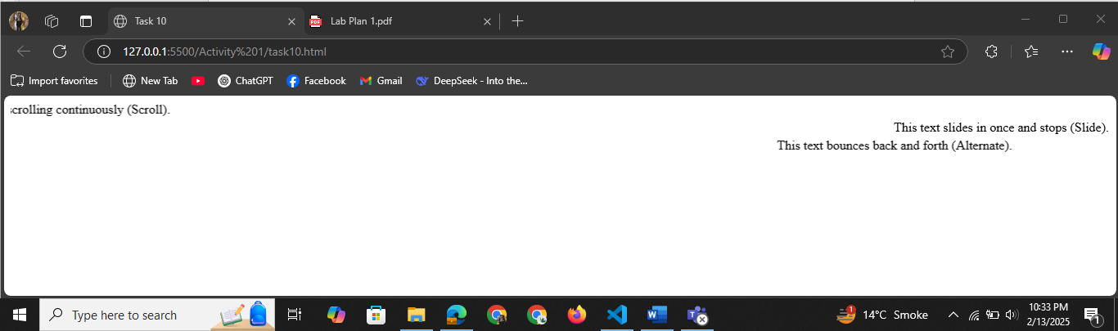

**Lab No.2**

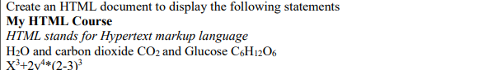**Task 1:**

**<!DOCTYPE html>**

**<html lang="en">**

**<head>**

**<meta charset="utf-8">**

**<meta name="viewport" content="width=device-width, initial-scale=1.0">**

**<title>Task 1 </title>**

**</head>**

**<body>**

**<b>My HTML Course</b><br>**

**<i>HTML stands for Hypertext markup language </i>**

**<p>H<sub>2</sub>O and carbon dioxide CO<sub>2</sub> and Glucose C<sub>6</sub>H<sub>12</sub>O<sub>6</sub></p>**

**<p>X<sup>3</sup>+2y<sup>4</sup>*(2-3)<sup>3</sup></p>**

**</body>**

**</html>**

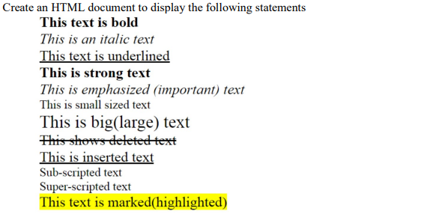**Task 2:**

**<!DOCTYPE html>**

**<html lang="en">**

**<head>**

**<meta charset="utf-8">**

**<meta name="viewport" content="width=device-width, initial-scale=1.0">**

**<title>Task 2 </title>**

**</head>**

**<body>**

**<b>This text is bold</b><br>**

**<i>This is an italic text</i><br>**

**<u>This text is underline</u><br>**

**<strong>This is strong text</strong><br>**

**<em>This is emphasized(important) text</em><br>**

**<small>This is small sized text</small><br>**

**<big>This is big(large) sized text</big><br>**

**<!-- <del> can also used for it -->**

**<strike>This shows deleted text</strike>**

**<ins>This is inserted text</ins>**

**<p>Sub<sub>-scripted </sub>Text</p>**

**<p>Sup<sup>-scripted </sup>Text</p>**

**<mark>This text is marked(highlighted)</mark>**

**</body>**

**</html>**

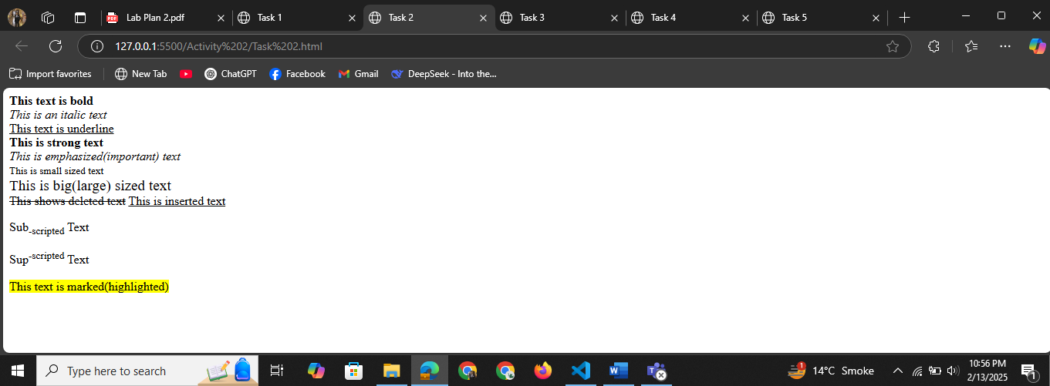

**Task 3:**

**<!DOCTYPE html>**

**<html lang="en">**

**<head>**

**<meta charset="UTF-8">**

**<meta name="viewport" content="width=device-width, initial-scale=1.0">**

**<title>Static web page</title>**

**</head>**

**<body>**

**<div style="background-color: orange; padding:20-px">**

**<h1>Content1 of div tag in Html</h1>**

**<p>Div tag is used for group many HTML tag like table, list, paragrapgh in web page.**

**Mostly div tag used in empty web page to partition orr make section for content of HTML tags.</p>**

**</div>**

**<div style="background-color: yellow;">**

**<h1>content2 of div tag in Html</h1>**

**<p>To make section of required data or content multiple div tags are used in container.**

**Example: header,foter,navigation bar,table,images,texts etc**

**</p>**

**</div>**

**</body>**

**</html>**

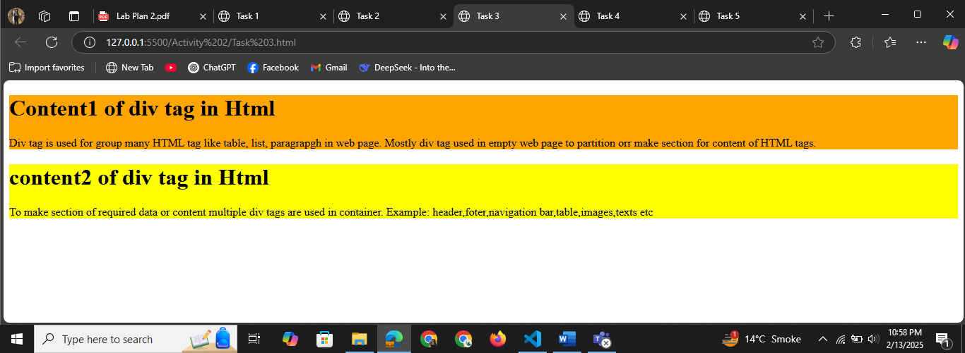

**Task 4:**

**<!DOCTYPE html>**

**<html lang="en">**

**<head>**

**<meta charset="UTF-8">**

**<meta name="viewport" content="width=device-width, initial-scale=1.0">**

**<title>Document</title>**

**</head>**

**<body>**

**<h1 style="background-color: yellow;">Content1 of div tag in Html</h1>**

**<p style="background-color: orange;">Div tag is used for group many HTML tag like table, list, paragrapgh in web**

**page.**

**Mostly div tag used in empty web page to partition orr make section for content of HTML tags.</p>**

**<h1 style="background-color: yellow">content2 of div tag in Html</h1>**

**<p style="background-color:orange">To make section of required data or content multiple div tags are used in**

**container.**

**Example: header,foter,navigation bar,table,images,texts etc**

**</p>**

**</body>**

**</html>**

**Task 5:**

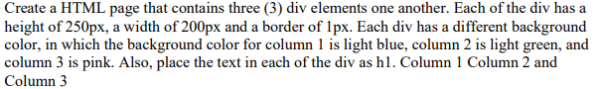

**<!DOCTYPE html>**

**<html lang="en">**

**<head>**

**<meta charset="utf-8">**

**<meta name="viewport" content="width=device-width, initial-scale=1.0">**

**<title>Task 5 </title>**

**</head>**

**<body style="display:flex">**

**<div style="background-color:lightblue; height: 250px; width:200px; border: 1px solid black;">**

**<h1 style="text-align: center;">Column 1</h1>**

**</div>**

**<div style="background-color:lightgreen; height: 250px; width:200px; border: 1px solid black;">**

**<h1 style="text-align: center;">Column 2</h1>**

**</div>**

**<div style="background-color:pink; height: 250px; width:200px; border: 1px solid black;">**

**<h1 style="text-align: center;">Column 3</h1>**

**</div>**

**</body>**

**</html>**

**Task 6:**

**<!DOCTYPE html>**

**<html lang="en">**

**<head>**

**<meta charset="utf-8">**

**<meta name="viewport" content="width=device-width, initial-scale=1.0">**

**<title>Task 6 </title>**

**<style>**

**.container {**

**display: flex;**

**width: 90%;**

**border: 3px solid black;**

**}**

**.left {**

**width: 50%;**

**}**

**.right {**

**width: 50%;**

**}**

**.inner {**

**border: 2px solid black;**

**height: 200px;**

**margin: 10px;**

**}**

**</style>**

**</head>**

**<body>**

**<div class="container">**

**<div class="left">**

**<h1>This is the title</h1>**

**<p>Lorem ipsum dolor sit amet, quodsi saperet vocibus cum ei, id doctus labores constituto eos, cu accusamus disputando mediocritatem ius. Vis in sensibus interesset, ut aperiam vulputate sed. Pri populo noster et, eirmod melius</p>**

**</div>**

**<div class="right">**

**<div class="inner"></div>**

**</div>**

**</div>**

**</body>**

**</html>**

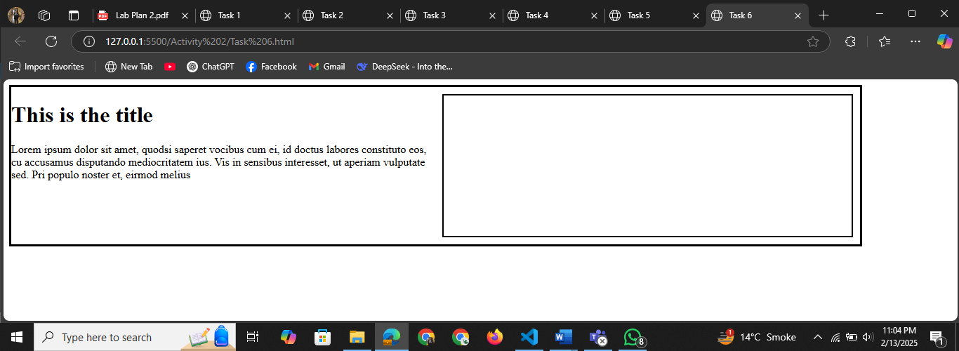

**Task 7:**

**<!DOCTYPE html>**

**<html lang="en">**

**<head>**

**<meta charset="utf-8">**

**<meta name="viewport" content="width=device-width, initial-scale=1.0">**

**<title>Task 7 </title>**

**<style>**

**.container {**

**width: 100%;**

**}**

**.left-div {**

**height: 100px;**

**width: 40%;**

**background-color: brown;**

**border: 2px solid black;**

**}**

**.left {**

**display: flex;**

**margin-right: 3.8%;**

**float: right;**

**width: 40%;**

**}**

**.right-div {**

**margin-left: 30%;**

**width: 40%;**

**border: 2px solid black;**

**background-color: brown;**

**height: 100px;**

**}**

**.right {**

**display: flex;**

**width: 80%;**

**}**

**</style>**

**</head>**

**<body>**

**<div class="container">**

**<div class="left">**

**<div class="left-div">**

**Fluid Div 40%**

**<br><br><br>**

**<p style="text-align:right ;">Inner Div</p>**

**</div>**

**</div>**

**<div class="right">**

**<div class="right-div">**

**Fluid Div 60%**

**</div>**

**</div>**

**</div>**

**</body>**

**</html>**

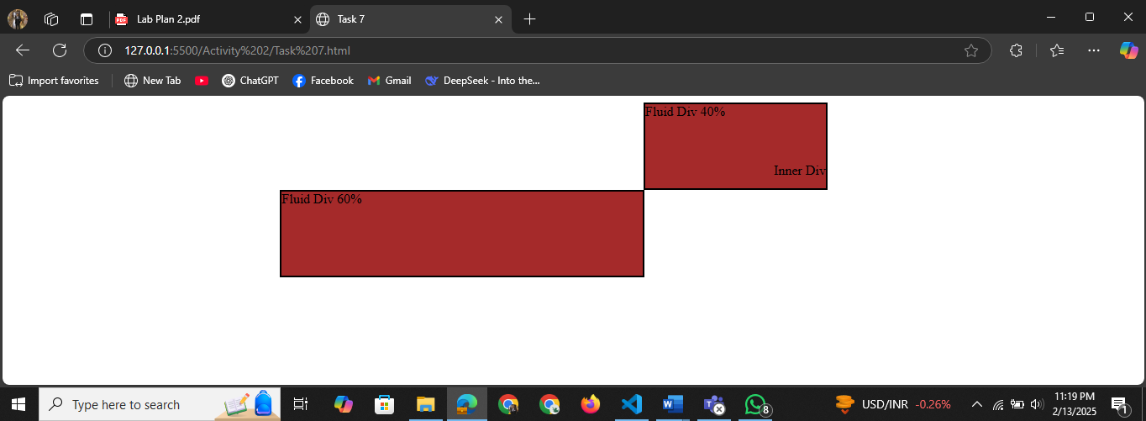

**Task 8:**

**<!DOCTYPE html>**

**<html lang="en">**

**<head>**

**<meta charset="utf-8">**

**<meta name="viewport" content="width=device-width, initial-scale=1.0">**

**<title>Task 8 </title>**

**</head>**

**<body>**

**<p>**

**<b>Ammonia's chemical formula is:</b> NH <sub>3</sub><br>**

**<b>Ethanol's chemical formula is:</b> C<sub>2</sub>H<sub>5</sub>O<br>**

**x<sup>2</sup>+y<sup>2</sup>=r<sup>2</sup><br>**

**(a+b)<sup>2</sup>=a<sup>2</sup>+b<sup>2</sup>+2ab<br>**

**5th**

**</p>**

**</body>**

**</html>**

**Task 9:**

**<!DOCTYPE html>**

**<html lang="en">**

**<head>**

**<meta charset="utf-8">**

**<meta name="viewport" content="width=device-width, initial-scale=1.0">**

**<title>Task 9</title>**

**</head>**

**<body>**

**<h1>Formatting Text</h1>**

**<p>font size-7: <font size="7">HTML</font></p>**

**<p>font size-3: <font size="3">HTML</font></p>**

**<p>font color-"red": <font color="red">HTML</font></p>**

**<p>font size-6 and color -red: <font size="6" color="red">HTML</font></p>**

**<p>bold, underline and italic: <font size="6" color="red"><b><u><i>Text</i></u></b></font>**

**</p>**

**<p>Bold: <font size="6" color="red"><b>HTML</b></font>**

**</p>**

**<p>Strong: <strong>HTML</strong></p>**

**<p>Underline: <u>HTML</u></p>**

**<p>Ins: <ins>HTML</ins></p>**

**<p>Italic: <i>HTML</i></p>**

**<p>Emapasis: <em>HTML</em></p>**

**<p>Strike: <strike>HTML</strike></p>**

**<p>Del: <del>HTML</del></p>**

**<p>Highlighting a text: <mark>HTML</mark></p>**

**</body>**

**</html>**

**Task 10:**

<!DOCTYPE html>

<html lang="en">

<head>

    <meta charset="utf-8">

    <meta name="viewport" content="width=device-width, initial-scale=1.0">

    <title>Task 10 </title>

    <style>

        .container {

          display: flex;

          width: 70%;

          border: 3px solid black;

        }

        .left {

          width: 30%;

        }

        .right {

            margin-left: auto;

          width: 50%;

        }

        .inner {

          border: 2px solid black;

          height: 200px;

          margin: 10px;

        }

        </style>

</head>

<body>

    <div class="container">

        <div class="left">

            <div class="inner"></div>

          </div>

        <div class="right">

          <h1>This is the title</h1>

          <p>Lorem ipsum dolor sit amet, quodsi saperet vocibus cum ei, id doctus labores constituto eos, cu accusamus disputando mediocritatem ius. Vis in sensibus interesset, ut aperiam vulputate sed. Pri populo noster et, eirmod melius</p>

        </div>

      </div>

</body>

</html>

